KUKA KR 6 R900 sixx

Base Structure

A solid, strong base was required for a robust and smooth motion of the robot. After discussing different base settings of it, a simple design that consists of a cylindrical body, that will carry the robot, with upper and lower flanges, was chosen.

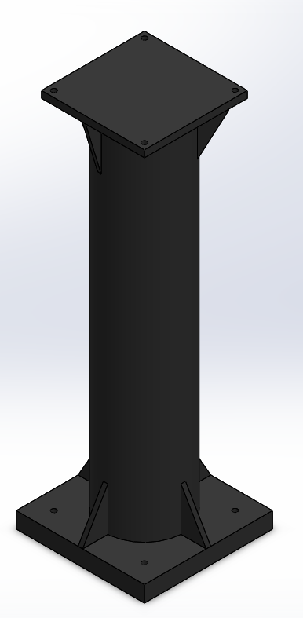

Fig. 1: Base Structure

It is mainly consisted of:

1. Two lower flanges:

- First flange is connected to the ground and is held strongly by the concrete layer beneath it

- Second flange connects the cylindrical body of the base to the previously mentioned flange.

1. The cylindrical body that carries the robot. It’s mounted on the Second lower flange to stand still while the robot is operated at full speed.
2. One upper flange which holds the robot and is welded to the cylinder.
3. Ribs: there are 4 upper and lower ribs evenly distributed on the upper and lower flanges, that helps to support the loads exerted on the cylinder.

Base calculation

This section discusses the process of calculating the following:

1. Cylinder

- The inner and outer diameters of the cylinder (which is hollow)

1. Flanges:

- The dimensions (length x width) of the 3 flanges

- The exact locations of the holes through which the bolts will be screwed

- The thickness of the flanges

1. Bolts

- The diameters of all bolts used in the installation and mounting of the base.

1. Ribs

- The dimensions of the triangular ribs (height x width x thickness)

1. The inner and outer diameters of the cylinder

Since the cylindrical body of the base is subjected to different axial and torsional loads, it will be treated as a shaft

1. Determining the diameters (Forward design method)

1st design attempt is to design the cylinder using the predefined specifications of the commercial materials in the market to get the inner and outer diameters. After several weeks of calculating and repetition, the results were within the range of 10-2 to 10-3 mm, which led us to the Second method of design.

1. Design based on strength

Second attempt is aimed to use the inner and outer diameters of the cylinders available in the market, to check whether the resulting max shear stress would exceed the max allowable shear stress or not. The ASME code for such method is:

$$τ_{allowable}= \frac{16}{π d_{o}^{3} (1-k^{4})} \sqrt{{(K_{b} M_{b}+ \frac{F_{a} d_{o} (1+ k^{2})}{8})}^{2}+{(K_{t} M_{t})}^{2}}$$

Where

* Combined shock and fatigue factors: $K_{b}= K_{t}=1 :2$
* Bending Moment: $M_{b}$ $M_{b}=H F_{h}$
* Torsional Moment: $M_{t}$
* Axial Force: $F_{a}$
* Constant k: $k= \frac{d_{i}}{d_{o}}$
* Max Allowable shear stress of a predefined specifications of a material, without keyways:
$$τ_{all}=0.3 σ_{y}$$

$$τ_{all}=0.18 σ_{u}$$

* These values shall be reduced by 25% in the presence of keyways
* Max Allowable shear stress of commercial steel:

$τ_{all}=55 MPa$ without keyways

$τ_{all}=40 MPa$ with keyways

Using the following values of loads exerted on the foundation, we can calculate the max shear stress.

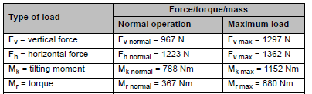  
Table 1: Loads acting on foundation.

* *Note: For safety purposes, Kb & Kt will be taken as 2 in the calculations*

Results:

Using steel A37 with the following specifications:

* + Yield Strength: $σ_{y}=235 MPa$
  + Ultimate Tensile Strength: $σ_{u}=360 MPa$

Hence, the max allowable shear stress is:

$$τ_{all}=0.3 σ_{y}=70.5 MPa$$

$$τ_{all}=0.18 σ_{u}=64.8 MPa$$

|  |  |  |
| --- | --- | --- |
| Outer Diameter | Inner Diameter | Shear Stress |
| 170 mm | 160 mm | 13.68 Mpa |
| 220 mm | 208 mm | 6.792 Mpa |
| 220 mm | 210 mm | 8.041 Mpa |

1. Bolts’ diameters

To calculate the diameters of the used bolts we need to calculate the tension forces acting on them first.

$$M_{b}= 2F_{1}r_{1}+2 F_{2}r_{2}= H F_{h}$$

$\frac{F_{1}}{F_{2}}=\frac{r_{1}}{r_{2}}$*→ $F_{1}= F_{2}\frac{r_{1}}{r_{2}}$*

$$∴ H F_{h}= 2F_{2} ( \frac{r_{1}^{2}}{r_{2}}+ r_{2} )$$

Where: r1 and r2 are the distance from one edge of the flange to the first pair of bolts, and the second pair respectively.

* *Note: The dimension of the flanges and the distances r1 and r2 are assumed, until reasonable results are gained by try and error*

Once we get the tension forces we can calculate the diameter and number of bolts as follows:

$$σ_{t}= \frac{F_{t}}{\frac{π}{4} d^{2}}$$

$$F_{t}= \frac{2 M_{t}}{d_{c} n_{bolt}}$$

1. Dimensions of the flanges

As previously mentioned, the dimensions (length x width) of the flanges are gained by try and error because they are used simultaneously in calculating the diameter of the bolts.

The thickness of the flange is calculated by:

$$σ_{br}= \frac{F_{t}}{ t d^{2}}$$

However, the thickness of available steel sheets in market is 10 mm.

1. Ribs

The ribs are made of the same sheet of which the flanges are made of, thus, the hickness of the ribs is 10 mm.

There isn’t an exact way of calculating the height and width of the triangular ribs. After discussing the matter with several machine design doctors, we concluded that ribs’ width should cover the length from the cylinder surface to the edge of the flange, and the height ranges from 90 to 100 mm. the constructed ribs have a height of 90 mm.

………………………………………………………………………………

Regarding the documentation:

- There are still illustrative figures of the base at each section that are missing, & data (numbers) of the calculations still hasn’t been mentioned.

- The phrasing will be revised.